SMART HOSTEL MANAGEMENT SYSTEM
A PROJECT REPORT

Submitted by

SANJAY M 220701246
SHYAM S 220701508

in partial fulfillment for the award of the degree
of
BACHELOR OF ENGINEERING
in
COMPUTER SCIENCE ENGINEERING


RAJALAKSHMI ENGINEERING COLLEGE, CHENNAI

ANNA UNIVERSITY : CHENNAI 600 025
OCTOBER 2025

BONAFIDE CERTIFICATE

This is to certify that the project report entitled “SMART HOSTEL MANAGEMENT SYSTEM” submitted by SANJAY M (220701246), SHYAM S (220701508) of the Department of Computer Science and Engineering, Rajalakshmi Engineering College, has been carried out under my supervision in partial fulfillment of the requirements for the course Cloud Computing.

SIGNATURE SIGNATURE
Dr. E. M. Malathy, M.E., Ph.D., M. Santhiya, M.E.
Professor and Head Assistant Professor,
Department of Computer Science Department of Computer Science
and Engineering, and Engineering,
Rajalakshmi Engineering College, Rajalakshmi Engineering College,
Chennai - 602 105. Chennai - 602 105.

Submitted to Project Viva-Voce Examination held on __________________

INTERNAL EXAMINER EXTERNAL EXAMINER

ABSTRACT
Smart Hostel Management System is a cloud-based web application designed to automate and streamline hostel administration processes in educational institutions. Traditional hostel management still relies on manual record keeping for room allocation, fee payment, attendance, visitor logs, and grievance tracking. These manual processes often result in errors, delays, data inconsistency, lack of transparency, and increased administrative workload. The Smart Hostel Management System integrates all these operations into a unified digital platform hosted on Microsoft Azure to ensure high availability, security, and scalability.
The application is built using a React-based frontend for a responsive user interface and a Node.js–Express backend for API and business logic execution. Hostel data such as student profiles, room allocations, and payment histories are stored securely in Azure SQL Database. Documents, ID proofs, grievance files, and system logs are maintained in Azure Blob Storage. Sensitive credentials like database connection strings and API keys are protected using Azure Key Vault. All services are containerized with Docker, and the images are stored in Azure Container Registry. Automated deployment is achieved through GitHub Actions CI/CD pipelines, while infrastructure provisioning and version control are implemented using Terraform (IaC).
The platform also includes an intelligent chatbot powered by Azure OpenAI Service. This chatbot provides real-time support to students and hostel administrators by answering queries related to room rules, mess schedules, visitor guidelines, and fee/complaint status. The chatbot references institutional rulebooks and announcements stored in Blob Storage to deliver accurate, context-aware responses.

ACKNOWLEDGEMENT

Initially we thank the Almighty for being with us through every walk of our life and showering his blessings through the endeavor to put forth this report. Our sincere thanks to our Chairman Mr. S.MEGANATHAN, B.E, F.I.E., our Vice Chairman Mr. ABHAY SHANKAR MEGANATHAN, B.E., M.S., and our respected Chairperson Dr. (Mrs.) THANGAM MEGANATHAN, Ph.D., for providing us with the requisite infrastructure and sincere endeavoring in educating us in their premier institution.

Our sincere thanks to Dr. S.N. MURUGESAN, M.E., Ph.D., our beloved Principal for his kind support and facilities provided to complete our work in time. We express our sincere thanks to Dr. E.M. MALATHY, M.E., Ph.D., Professor and Head of the Department of Computer Science and Engineering for her guidance and encouragement throughout the project work. We convey our sincere and deepest gratitude to our internal guide, Dr. M. Ayyadurai, Associate Professor, Department of Computer Science and Engineering for his valuable guidance throughout the course of the project.

SANJAY M (220701246)

SHYAM S (220701508)

TABLE OF CONTENTS
CHAPTER NO | TITLE | PAGE NO
 | ABSTRACT | I
 | LIST OF TABLES | ii
 | LIST OF FIGURES | iv
 | LIST OF ABBREVIATIONS | v
1 | INTRODUCTION | 1
 | 1.1 PROBLEM STATEMENT | 1
 | 1.2 OBJECTIVE | 1
 | 1.3 SCOPE AND BOUNDARIES | 2
 | 1.4 STAKEHOLDERS AND END USERS | 2
 | 1.5 TECHNOLOGIES USED | 3
 | 1.6 ORGANIZATION OF THE REPORT | 4
2 | SYSTEM DESIGN AND ARCHITECTURE | 5
 | 2.1 REQUIREMENT SUMMARY | 5
 | 2.1.1 FUNCTIONAL REQUIREMENTS | 5
 | 2.1.2 NON-FUNCTIONAL REQUIREMENTS | 6
 | 2.2 PROPOSED SOLUTION OVERVIEW | 6
 | 2.3 CLOUD DEPLOYMENT STRATEGY | 7
 | 2.4 INFRASTRUCTURE REQUIREMENTS | 8
 | 2.5 AZURE SERVICES MAPPING AND JUSTIFICATION | 9
3 | DEVOPS IMPLEMENTATION | 10
 | 3.1 CONTINUOUS INTEGRATION AND DEPLOYMENT(CI/CD) SETUP | 11
 | 3.2 TERRAFORM INFRASTRUCTURE-AS-CODE(IAC) | 11
 | 3.3 CONTAINERIZATION STRATEGY(DOCKER) | 12
 | 3.4 GENAI INTEGRATION AND AZURE AI SERVICE MAPPING | 13
4 | CLOUD OPERATIONS AND SECURITY | 15
 | 4.1 DEVSECOPS INTEGRATION | 15
 | 4.2 MONITORING AND OBSERVABILITY | 15
 | 4.3 ACCESS CONTROL | 16
 | 4.4 BLUE-GREEN DEPLOYMENT & DISASTER RECOVER PLANNING | 17
5 | RESULTS AND DISCUSSION | 18
 | 5.1 IMPLEMENTATION SUMMARY | 18
 | 5.2 CHALLENGES FACED AND RESOLUTIONS | 19
 | 5.3 PERFORMANCE OR COST OBSERVATIONS | 20
 | 5.4 KEY LEARNINGS AND TEAM CONTRIBUTIONS | 20
6 | CONCLUSION AND FUTURE ENHANCEMENT | 22
 | 6.1 CONCLUSION | 22
 | 6.2 FUTURE SCOPE | 23
 | REFERENCES | 25
 | APPENDICES | 26

LIST OF TABLES

TABLE NO | TABLE NAME | PAGE NO
2.4 | INFRASTRUCTURE REQUIREMENTS | 9
2.5 | AZURE SERVICES MAPPING AND JUSTIFICATION | 9
5.2 | CHALLENGES FACED AND RESOLUTIONS | 19

LIST OF FIGURES

FIGURE NO | FIGURE NAME | PAGE NO
1 | LOGIN PAGE | 35
2 | ADMIN DASHBOARD | 35
3 | STUDENT MANAGEMENT PAGE | 36
4 | ROOM MANAGEMENT PAGE | 36
5 | FEES MANAGEMENT PAGE | 37

LIST OF ABBREVIATIONS

AI | Artificial Intelligence
API | Application Programming Interface
SQL | Structured Query Language
IaC | Infrastructure as Code
RBAC | Role-Based Access Control
ACR | Azure Container Registry
PaaS | Platform as a Service
DBaaS | Database as a Service
HTTP | HyperText Transfer Protocol
GPT | Generative Pre-trained Transformer
OWASP ZAP | Open Web Application Security Project – Zed Attack Proxy
XSS | Cross-Site Scripting
CPU | Central Processing Unit
DR | Disaster Recovery
GRS | Geo-Redundant Storage (used in Azure Storage)
YAML | YAML Ain’t Markup Language
CI/CD | Continuous Integration / Continuous Delivery
AKS | Azure Kubernetes Service

CHAPTER 1 – INTRODUCTION

PROBLEM STATEMENT
In many educational institutions, hostel management activities such as room allocation, fee payments, attendance tracking, visitor record keeping, and grievance handling are still performed manually or with limited digital support. These traditional methods often result in data duplication, administrative delays, human errors, difficulty in tracking records, and lack of real-time visibility for both students and hostel administrators. Important tasks like fee due reminders, maintenance requests, occupancy status updates, and policy communications are time-consuming and inconsistent across departments. Additionally, students often need to contact hostel authorities directly for even simple information, leading to miscommunication and workload stress. Therefore, there is a need for a centralized, secure, and automated cloud-based solution that ensures transparency, data accuracy, and smoother interaction between students and hostel administration.

OBJECTIVE
The main objective of the Smart Hostel Management System is to digitally transform hostel operations using cloud-based technologies and provide a seamless experience for students and hostel administrators.
The specific objectives are:
- To develop a centralized web portal for room allocation, fee payment, and student management.
- To store hostel data securely using Microsoft Azure cloud services for reliability and scalability.
- To implement digital receipt generation, automated due reminders, and real-time occupancy updates.
- To integrate a chatbot powered by Azure OpenAI Service for answering hostel-related queries.
- To automate deployments using DevOps tools such as Docker, Azure Container Registry, GitHub Actions, and Terraform.
- To ensure secure access control using Azure Role-Based Access Control (RBAC) and Azure Key Vault for credential management.

SCOPE AND BOUNDARIES
Scope of the system includes:
- Student registration and profile management
- Room allotment and hostel availability monitoring
- Hostel fee payment, history tracking, and receipt generation
- Visitor entry logging and verification
- Grievance and maintenance request submission
- AI-based chatbot assistance for policy and inquiry responses
Boundaries / Limitations:
- The system currently focuses on hostel management only and does not manage tuition fees or academic records.
- The chatbot responses are limited to hostel rules and documents uploaded into Azure Blob Storage.
- Mobile application support is not included in the current implementation but may be added in the future.

STAKEHOLDERS AND END USERS
The primary users of the system are students who reside in the hostel. They use the system to manage their room details, make fee payments, submit complaints, and receive notifications. Hostel wardens and hostel administrative staff use the system to manage student information, approve room allotment and changes, monitor occupancy, and handle grievances. The finance team uses the system to verify payment histories and generate reports. System administrators maintain the platform, ensure uptime, and handle user access levels. Higher-level institutional authorities may use the system for monitoring hostel operations and decision-making.

1.5 TECHNOLOGIES USED

The Smart Hostel Management System is developed using modern web technologies and Microsoft Azure cloud services. The frontend is developed using React.js to provide a clear and responsive interface for user interaction. The backend is implemented using Node.js and Express to manage server-side logic and database communication. Azure SQL Database is used for secure and scalable data storage. Azure Blob Storage is used for storing documents such as receipts and student identification proofs. Azure Key Vault is used for securing sensitive credentials. Docker is used for containerizing the application, and Azure Container Registry is used to store and manage container images. The system is deployed using Azure App Service for Containers. GitHub Actions is used to automate CI/CD workflows, and Terraform is used for Infrastructure-as-Code. An intelligent chatbot is integrated using Azure OpenAI Service for answering hostel-related queries.

1.6 ORGANIZATION OF THE REPORT
This report has six chapters:
- Chapter 1 introduces the project, including the problem statement, objectives, and technologies used.
- Chapter 2 presents the system architecture, design, and deployment strategy on Azure Cloud.
- Chapter 3 describes the DevOps and automation pipeline, including Terraform and Docker setup.
- Chapter 4 explains the cloud operations, monitoring, and security strategies implemented.
- Chapter 5 discusses the outcomes, challenges faced, and overall performance analysis.
- Chapter 6 wraps up the report and outlines future enhancements for the TransPay platform.

CHAPTER 2 – SYSTEM DESIGN AND ARCHITECTURE

2.1 REQUIREMENT SUMMARY
The Smart Hostel Management System is designed to digitalize the core hostel activities such as room allocation, fee payments, visitor entry logs, and grievance management. To accomplish this, the system must provide secure access, accurate record-keeping, efficient interactions, and scalable performance on the cloud.

2.1.1 FUNCTIONAL REQUIREMENTS
- User Authentication:
Students and hostel staff should be able to log in using secure credentials to access their respective portals.
- Student Profile and Room Allocation:
Students must be able to view their room details, and wardens should be able to allocate, modify, or free rooms as required.
- Hostel Fee Payment:
Students should be able to make hostel fee payments online, and payment records must be stored securely.
- Receipt Generation:
After a successful payment, the system should automatically generate a digital receipt and store it for future reference.
- Visitor Management:
A visitor entry logging system should record visitor information and ensure secure verification by hostel authorities.
- Grievance and Maintenance Requests:
Students should be able to submit complaints or requests, and wardens should track and respond to them.
- Chatbot Support:
The integrated AI chatbot must answer queries related to hostel rules, schedules, fee deadlines, and visitor policies.

2.1.2 NON-FUNCTIONAL REQUIREMENTS
- Scalability:
The system must support large numbers of users, especially during hostel announcement periods.
- Availability:
The platform should remain accessible at all times, even during peak usage.
- Security:
Hostel data, identity proofs, credentials, and payment details must be stored and transmitted securely.
- Performance:
Page responses and queries should be processed quickly without noticeable delays.
- Maintainability:
The development and deployment process must be automated to allow easy updates and error-free maintenance.
.
2.2 PROPOSED SOLUTION OVERVIEW
The Smart Hostel Management System is implemented as a cloud-hosted web application using Microsoft Azure services. The system consists of a React-based frontend for user interaction and a Node.js Express backend to manage application logic. All hostel data such as student information, room status, visitor logs, and payment history is stored in Azure SQL Database, which ensures reliability and secure data access.
Documents such as payment receipts, ID proofs, and grievance attachments are stored in Azure Blob Storage. Sensitive information such as database keys and API credentials is secured using Azure Key Vault. The complete application is containerized using Docker, and containers are stored and version-controlled in Azure Container Registry. Deployment is automated using GitHub Actions and infrastructure provisioning is handled by Terraform. Additionally, an Azure OpenAI-based chatbot is integrated to support real-time student inquiry responses.

2.3 CLOUD DEPLOYMENT STRATEGY
The system uses a Platform as a Service (PaaS) model for running the application and database services.
Deployment Flow:
- Developers push source code to GitHub.
- GitHub Actions builds and tests the code.
- Docker images are created for the frontend and backend.
- Images are pushed to Azure Container Registry.
- Terraform provisions and configures Azure services.
- Azure App Service pulls the images and deploys them automatically.
This ensures:
- Faster deployment cycles
- Error-free environment consistency
- Easy rollback and monitoring

FIGURE 2.3 SYSTEM ARCHITECTURE
The proposed system architecture outlines the overview of how student and staff make transportation fee payment. Students and staff enrollment to the website are managed by the administrator. Students and staff can pay the payment through the web application which is built using React for the browser interface and Node.js and Express for managing the APIs of razorpay, and to interact with the Azure SQL server. Once the user pays the transportation fee through Razorpay, the receipt is generated and stored in the Azure Blob storage container of the Storage account in the azure cloud. The GPT-3.5 model is deployed using Azure OpenAI for answering the queries of the students and staff about the refund policies, payment due date, and any other queries related to the transportation fee payment.

2.4 INFRASTRUCTURE REQUIREMENTS
The below table outlines the components of azure cloud used and their purpose in developing the transport fee payment management platform.
Component | Service Type | Configuration / Plan | Purpose
App Service Plan | PaaS | B1 (Basic Tier) | Runs frontend and backend containers
Azure SQL Database | SQL Database | Basic Tier (5 DTUs) | Stores payment, user, and transaction data
Azure Storage Account | Blob Storage | Hot Access Tier | Stores receipts, policy docs, and chatbot embeddings
Azure Container Registry (ACR) | Container Repository | Standard | Stores and versions Docker images
Azure Key Vault | Security Service | Standard Tier | Manages secrets, API keys, and connection strings
Azure Monitor / App Insights | Observability | Default Plan | Provides logs, metrics, and alerting
Resource Group | Resource Container | N/A | Logical grouping for all project components

TABLE 2.4 INFRASTRUCTURE REQUIREMENTS

2.5 AZURE SERVICES MAPPING AND JUSTIFICATION
The table depicts the azure services and resources used in the transportation fee payment management system.
Azure Service | Usage in Project | Justification
Azure App Service (Linux Containers) | Hosts the React frontend and Node.js backend Docker images | Provides a managed environment for containerized apps with minimal ops overhead
Azure SQL Database | Stores transaction details and user data | Offers automatic backups, scaling, and strong consistency
Azure Container Registry (ACR) | Stores Docker images for frontend and backend | Ensures secure, version-controlled container management
Azure Blob Storage | Stores receipts, documents, and embeddings for the chatbot | Cost-effective, scalable object storage solution
Azure Key Vault | Stores Razorpay and Auth0 secrets | Prevents credential exposure and supports RBAC-based access
Azure OpenAI Service | Hosts GPT-3.5 model for chatbot integration | Enables an AI-powered document-aware Q&A for user support
GitHub Actions (CI/CD) | Automates build, test, and deployment workflow | Ensures consistent and repeatable deployments
Terraform (IaC) | Defines and provisions Azure infrastructure | Reduces manual configuration and enables version-controlled environments

TABLE 2.5 AZURE SERVICES MAPPING AND JUSTIFICATION

CHAPTER 3 – DEVOPS IMPLEMENTATION
3.1 CONTINUOUS INTEGRATION AND DEPLOYMENT(CI /CD) SETUP
The Smart Hostel Management System follows an automated CI/CD pipeline to ensure faster development, testing, and deployment. The pipeline is implemented using GitHub Actions, which automatically triggers the workflow whenever a new update is pushed to the main branch of the repository.
In the Continuous Integration stage, GitHub Actions pulls the latest source code, installs required dependencies, and runs basic checks to ensure there are no errors in the build process. The React frontend is built into production-ready static files, and the Node.js backend is tested for API response stability.
During the Continuous Deployment stage, Docker images are created for both frontend and backend components. These images are tagged and securely pushed to Azure Container Registry (ACR). Once the updated images are available in ACR, Azure App Service automatically pulls the latest container version and deploys it to the cloud. This automated approach reduces manual intervention, minimizes deployment errors, and ensures that new features can be released quickly and consistently.

3.2 TERRAFORM INFRASTRUCTURE-AS-CODE(IAC)

The infrastructure required for hosting the application on Microsoft Azure is provisioned and managed using Terraform, which follows the Infrastructure-as-Code (IaC) methodology. Instead of manually setting up cloud services through the Azure portal, Terraform configuration files define all required components such as Resource Groups, App Service Plans, Azure SQL Database, Container Registry, Key Vault, and Storage Accounts.

The Terraform workflow includes:

Initialization using terraform init to set up providers.

Planning using terraform plan to preview changes before applying.

Provisioning using terraform apply to create or update resources.

State management to track changes and maintain consistent infrastructure.

Using Terraform allows the system to maintain version-controlled infrastructure, enabling easy replication across development, testing, and production environments. It also ensures scalability and reduces configuration errors.

3.3 CONTAINERIZATION STRATEGY(DOCKER)

The Smart Hostel Management System uses Docker to containerize both the frontend and backend components. Containerization provides a consistent runtime environment across all systems, ensuring that the application behaves the same regardless of where it is deployed.

The frontend container includes the React production build served through a lightweight web server.

The backend container includes Node.js and Express, along with required libraries to handle REST API operations.

The development workflow includes building and testing containers locally before pushing them to the cloud. After validation, the Docker images are pushed to Azure Container Registry, where they are stored securely and tagged by version. This makes rollback or updating to a previous version simple and reliable.

Containerization also makes the system more portable, scalable, and easier to manage during future updates or migrations.

3.4 GENAI INTEGRATION AND AZURE AI SERVICE MAPPING
A key feature of the TransPay project is the integration of a Generative AI Chatbot that provides contextual answers to transport-related questions. The chatbot uses GPT-3.5, hosted on Azure OpenAI Service, and connects to the backend through a secure API. It reduces the staff workload and enhances user engagement through intelligent, context-aware interaction.
Chatbot Workflow:
- The user asks a query (e.g., “Can I get a refund?”).
- The backend sends the query to the Azure OpenAI endpoint.
- The model retrieves relevant policy content from Blob Storage embeddings.
- GPT-3.5 processes the context and generates a policy-based response.
- The response will be displayed instantly on the chat interface in React.

CHAPTER 4 – CLOUD OPERATIONS AND SECURITY

4.1 DEVSECOPS INTEGRATION

Security is integrated throughout the development and deployment lifecycle of the Smart Hostel Management System using a DevSecOps approach. Instead of treating security as a final step, security checks are applied during coding, building, testing, and deployment stages.

The GitHub Actions CI pipeline includes automated security scanning to identify vulnerabilities in the source code and dependent libraries. Tools such as CodeQL analyze the backend to detect issues like SQL injection risks, insecure authentication logic, or unsafe data handling. Additionally, web application vulnerability scans such as OWASP ZAP are included during testing to identify threats such as Cross-Site Scripting (XSS), insecure redirects, and broken session validation.

All sensitive keys, database connection strings, and API credentials are stored securely in Azure Key Vault, preventing accidental exposure in code. Role-Based Access Control (RBAC) ensures that only authorized users can access specific cloud resources. By combining security automation, secret management, and policy enforcement, DevSecOps ensures that the system remains reliable and protected throughout its lifecycle.

4.2 MONITORING AND OBSERVABILITY

To maintain the reliability and performance of the application, the Smart Hostel Management System employs continuous monitoring and logging through Azure Monitor and Application Insights. These services collect real-time metrics such as CPU usage, memory consumption, database response times, request failures, and latency patterns.Administrators can view dashboards to track the health and usage of the system. Alerts are configured to notify the team in case of unusual activity, such as high server load, application crashes, or network failures. Application Insights provides detailed request tracing, which helps developers identify bottlenecks and resolve issues quickly. Centralized logging allows errors to be traced back to their root causes, enabling faster recovery and system stability. This observability setup ensures consistent system performance and improves the quality of future updates.

4.3 ACCESS CONTROL
Access to cloud resources and application interfaces is managed using Azure Role-Based Access Control (RBAC). RBAC ensures that users only receive the level of permissions required for their responsibilities, following the principle of least privilege.
- Hostel administrators are granted permissions to manage student allocations, payments, and complaints.
- Finance team members can view and verify payment records.
- Developers are allowed controlled access to deploy updates.
- System administrators manage identity controls, resource scaling, and service configurations.
Security groups and role assignments prevent unauthorized access to confidential data. Azure Active Directory authentication may also be used to enforce identity verification and secure login across all system modules.

4.4 BLUE-GREEN DEPLOYMENT & DISASTER RECOVERY PLANNING
To maintain continuous availability and reduce downtime during updates, the Smart Hostel Management System uses a Blue-Green Deployment strategy. Two identical environments run in parallel: the current live environment (Blue) and the new version under testing (Green). Once testing is successful, traffic is switched from Blue to Green with minimal interruption. If an issue occurs, traffic can be rolled back to the previous version instantly.
Disaster Recovery (DR) measures include:
- Azure SQL Database automatic backups, which include daily full backups, periodic differential backups, and transaction log backups.
- Geo-redundant storage (GRS) configuration in Azure Blob Storage to ensure document backups are replicated across regions.
- Redundant deployment zones, ensuring availability even during regional failures.
- Key Vault backup procedures to restore configuration and credentials securely.
These strategies ensure data integrity, high availability, and fast recovery from system or hardware failures.
CHAPTER 5 – RESULTS AND DISCUSSION
5.1 IMPLEMENTATION SUMMARY

The Smart Hostel Management System was successfully developed and deployed using Microsoft Azure cloud services. The system provides a centralized web interface for students and hostel administrators to manage hostel-related tasks such as room allocation, fee payments, visitor logs, and grievance submissions. The frontend was developed using React for a responsive interface, while the backend was built using Node.js and Express to handle business logic and database operations. Data is securely stored in Azure SQL Database, and documents such as receipts and uploaded files are maintained in Azure Blob Storage. The application was containerized using Docker and deployed using Azure App Service for Containers. GitHub Actions automated the CI/CD pipeline to ensure efficient and reliable deployments. Terraform was used for Infrastructure-as-Code to simplify provisioning and maintain consistency. An AI-based chatbot using Azure OpenAI Service was integrated to provide instant answers to hostel-related questions. Overall, the system fulfills its objective of improving operational efficiency and offering an automated, transparent, and user-friendly hostel management experience.

5.2 CHALLENGES FACED AND RESOLUTIONS

The below table depicts the challenges faced and troubleshooting and optimizing those challenges during implementation.
Challenge | Description | Resolution
Container Deployment Errors | Initial deployment to Azure App Service failed due to missing ACR permissions and environment variables. | Configured service principal credentials and linked ACR to App Service using managed identity.
Payment API Integration Issues | Razorpay webhook callbacks were not triggered due to incorrect endpoint mapping. | Updated callback URLs and tested the integration in Razorpay’s sandbox mode to ensure reliability.
Terraform Configuration Conflicts | Duplicate resource definitions caused provisioning errors. | Refactored .tf files into modules and reinitialized Terraform state.
Chatbot Context Retrieval | AI model produced generic responses without context. | Implemented embedding-based document search to retrieve context from policy files before GPT-3.5 response generation.
Pipeline Trigger Errors | GitHub Actions failed on conditional builds. | Adjusted YAML workflow syntax and added environment variables for branch-level control.

TABLE 5.2 CHALLENGES FACED AND RESOLUTIONS

5.3 PERFORMANCE OR COST OBSERVATIONS
After deployment and testing, the system demonstrated efficient performance and cost-effectiveness:
- The application maintained low response times and processed requests smoothly during peak usage.
- Azure SQL Database ensured fast data access and reliable storage without performance degradation.
- Hosting the application using Azure App Service for Containers provided scalability while minimizing resource overhead.
- Using Azure’s pay-as-you-go billing model ensured that operational costs remained manageable and only increased based on actual usage.
- The chatbot provided immediate responses, reducing the workload of hostel staff and improving user engagement.
Overall, the system provided an optimal balance between performance and resource cost.

5.4 KEY LEARNINGS AND TEAM CONTRIBUTIONS
The development of this system provided valuable hands-on experience in cloud computing, DevOps automation, web development, and AI integration. The project enhanced understanding of working with containerized applications, CI/CD pipelines, infrastructure provisioning using Terraform, and secure cloud deployment using Azure services. Integrating Azure OpenAI Service improved knowledge of conversational AI and document-based query handling.
Team members contributed by dividing responsibilities across frontend development, backend API implementation, cloud infrastructure setup, database configuration, DevOps pipeline creation, and chatbot integration. Collaboration and version control through GitHub ensured smooth coordination and code synchronization throughout the project.

CHAPTER 6 – CONCLUSION AND FUTURE ENHANCEMENT

6.1 CONCLUSION

The Smart Hostel Management System successfully demonstrates how cloud computing, DevOps automation, and AI-based interaction can transform and improve hostel administrative operations in educational institutions. The system replaces manual, paper-based processes with an efficient, centralized web platform that allows students and hostel staff to manage room allocations, fee payments, visitor entries, and grievances in a transparent and organized manner. By hosting the system on Microsoft Azure, the solution achieves reliability, scalability, and high availability, ensuring that hostel information is accessible at all times.
The use of Docker for containerization and Azure Container Registry for image management ensures consistent application performance across environments. The CI/CD pipeline built using GitHub Actions automates application deployment, minimizing human error and speeding up updates. Terraform-based Infrastructure-as-Code simplifies the creation and maintenance of Azure resources. Additionally, the integration of the Azure OpenAI-based chatbot enhances communication efficiency by instantly responding to student inquiries regarding hostel rules and procedures.
Overall, the Smart Hostel Management System fulfills its objectives of improving operational efficiency, reducing administrative workload, enhancing data accuracy, and providing a convenient user experience. It demonstrates how modern cloud technologies can effectively solve real-world institutional management challenges.

6.2 FUTURE SCOPE

Although the current system meets the core requirements of hostel management, several enhancements can be implemented to improve functionality and usability:
- Mobile Application Development:
A dedicated mobile app can be developed for Android and iOS to allow students and administrators to access hostel services anywhere with improved convenience.
- Advanced Analytics and Dashboard Insights:
Integration of Power BI or Azure Data Explorer can provide visual dashboards showing hostel occupancy trends, fee payment statistics, and maintenance history to support decision-making.
- IoT-Based Smart Monitoring:
IoT devices such as smart access locks, face recognition attendance systems, and energy monitoring sensors can be integrated for increased security and automation.
- Multi-Campus Support:
The system can be expanded to support multiple hostel branches across university campuses with centralized control.
- Voice-Enabled Chatbot Assistance:
The chatbot can be enhanced to support speech-to-text and voice-based interaction using Azure Cognitive Speech Services to make it more user-friendly.
- Integration with Mess and Transport Services:
The platform may be extended to include mess meal tracking, menu scheduling, transport allocation, and combined fee payment systems.
With these future improvements, the Smart Hostel Management System can evolve into a complete campus resource management platform that supports seamless and intelligent institutional operations.

REFERENCES
- Microsoft Learn – Azure App Service Documentation.
https://learn.microsoft.com/en-us/azure/app-service/
- Microsoft Learn – Azure SQL Database Overview.
https://learn.microsoft.com/en-us/azure/azure-sql/
- Microsoft Learn – Azure Blob Storage Documentation.
https://learn.microsoft.com/en-us/azure/storage/blobs/
- Terraform by HashiCorp – Azure Provider Guide.
https://registry.terraform.io/providers/hashicorp/azurerm/latest/docs
- Docker Documentation – Containerization Best Practices.
https://docs.docker.com/
- GitHub Actions Documentation – CI/CD Workflows.
https://docs.github.com/en/actions
- Razorpay Developer Documentation – Payment Gateway API Reference.
https://razorpay.com/docs/api/
- Azure OpenAI Service – GPT-3.5 API Reference.
https://learn.microsoft.com/en-us/azure/ai-services/openai/
- OWASP Foundation – Secure DevOps and Web Security Guidelines.
https://owasp.org/

APPENDICES

Appendix A – Terraform Code Snippet
Below is the Terraform configuration used for automating Azure resource provisioning for the TransPay project:
terraform {
required_providers {
azurerm = {
source = "hashicorp/azurerm"
version = "~> 3.100"
}
}
required_version = ">= 1.4.0"
}
provider "azurerm" {
features {}
}
# Use existing resource group
data "azurerm_resource_group" "rg" {
name = "project-one"
}
# Log Analytics Workspace
resource "azurerm_log_analytics_workspace" "law" {
name = "backend-law"
location = data.azurerm_resource_group.rg.location
resource_group_name = data.azurerm_resource_group.rg.name
sku = "PerGB2018"
retention_in_days = 30
}
# Container Registry
resource "azurerm_container_registry" "acr" {
name = "transport1east"
resource_group_name = data.azurerm_resource_group.rg.name
location = data.azurerm_resource_group.rg.location
sku = "Basic"
admin_enabled = false
}
# Use existing Container App Environment
data "azurerm_container_app_environment" "env" {
name = "backend-env"
resource_group_name = data.azurerm_resource_group.rg.name
}
# Container App
resource "azurerm_container_app" "backend" {
name = "backend-app"
resource_group_name = data.azurerm_resource_group.rg.name
container_app_environment_id = data.azurerm_container_app_environment.env.id
revision_mode = "Single"
identity {
type = "SystemAssigned"
}
ingress {
external_enabled = true
target_port = 3000
traffic_weight {
percentage = 100
latest_revision = true
}
}
template {
container {
name = "backend-container"
image = "${azurerm_container_registry.acr.login_server}/mybackend:latest"
cpu = 0.5
memory = "1.0Gi"
env {
name = "AZURE_STORAGE_CONNECTION_STRING"
value = var.storage_connection_string
} } }
registry {
server = azurerm_container_registry.acr.login_server
identity = "System"
}
}
# Assign AcrPull role to Container App’s Managed Identity
resource "azurerm_role_assignment" "acr_pull_system" {
scope = azurerm_container_registry.acr.id
role_definition_name = "AcrPull"
principal_id = azurerm_container_app.backend.identity[0].principal_id
depends_on = [
azurerm_container_app.backend
]
lifecycle {
prevent_destroy = true
ignore_changes = all
}
}

Appendix B – GitHub Actions CI/CD Workflow (YAML Snippet)
The following YAML file defines the CI/CD process for building and deploying Docker containers to Azure App Service:
trigger:
branches:
include:
- main

variables:
pythonVersion: '3.10'
nodeVersion: '20.x'
backendAppService: 'SmartHostelManagement'
frontendAppService: 'SmartHostelManagementSystem-Frontend'
azureServiceConnection: 'AzureDevOpsConnection'

stages:
# --------------------- Backend Stage ---------------------
- stage: Backend
displayName: 'Build & Deploy Backend (Django)'
jobs:
- job: BuildBackend
displayName: 'Build Backend'
pool:
vmImage: 'ubuntu-latest'
steps:
- task: UsePythonVersion@0
inputs:
versionSpec: '$(pythonVersion)'
- script: |
cd Backend
python -m venv venv
source venv/bin/activate
python -m pip install --upgrade pip
pip install -r requirements.txt
python manage.py collectstatic --noinput
zip -r release.zip . -x "__pycache__/*" -x "*.git/*" -x "venv/*"
displayName: 'Install dependencies & Collect Static Files'
- publish: Backend/release.zip
artifact: backendArtifact
displayName: 'Publish Backend Artifact'

- job: DeployBackend
displayName: 'Deploy Backend to Azure App Service'
dependsOn: BuildBackend
pool:
vmImage: 'ubuntu-latest'
steps:
- download: current
artifact: backendArtifact
- task: AzureWebApp@1
inputs:
azureSubscription: 'AzureDevOpsConnection'
appName: '$(backendAppService)'
package: '$(Pipeline.Workspace)/backendArtifact/release.zip'
deploymentMethod: 'zipDeploy'

# --------------------- Frontend Stage ---------------------
- stage: Frontend
displayName: 'Build & Deploy Frontend (React)'
jobs:
- job: BuildFrontend
displayName: 'Build Frontend'
pool:
vmImage: 'ubuntu-latest'
steps:
- task: NodeTool@0
inputs:
versionSpec: '$(nodeVersion)'
- script: |
cd frontend
npm install
npm run build || exit 1
displayName: 'Install dependencies & Build React'
- script: ls -al $(Build.SourcesDirectory)/frontend/dist
displayName: 'List Frontend Build Directory'
- publish: $(Build.SourcesDirectory)/frontend/dist
artifact: frontendArtifact
displayName: 'Publish Frontend Build Artifact'

- job: DeployFrontend
displayName: 'Deploy Frontend to Azure Static Web App'
dependsOn: BuildFrontend
pool:
vmImage: 'ubuntu-latest'
steps:
- download: current
artifact: frontendArtifact
- task: AzureStaticWebApp@0
inputs:
app_location: 'frontend'
output_location: 'frontend/dist'
azure_static_web_apps_api_token: '286aaa03937a577c4b8fb73c39aef3be45c6ca3df0169a4cf29ff557b8d5b8ee01-eb1adce7-c007-4ab4-892b-e3fd016f7cb5000031101402d100'
skip_app_build: true

Appendix C – Deployment andDashboard Screenshots
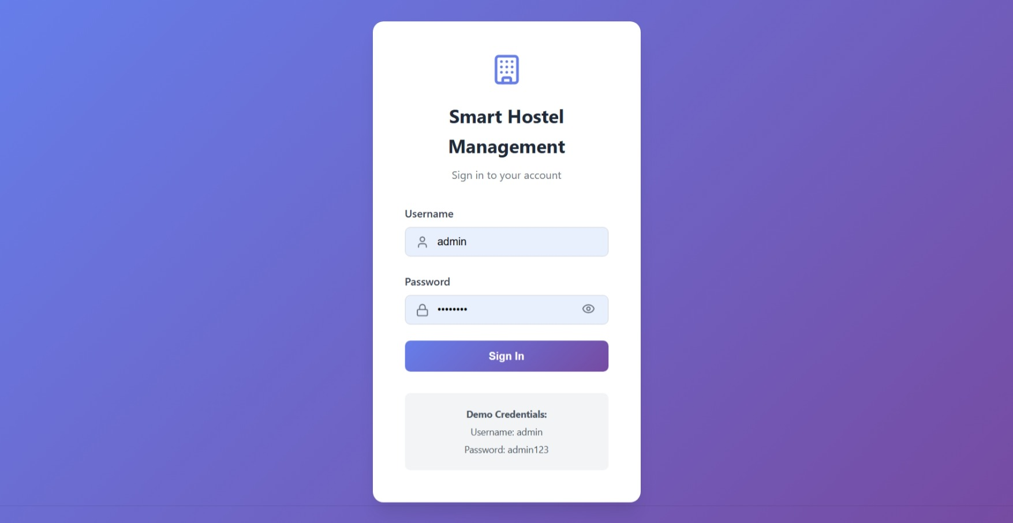

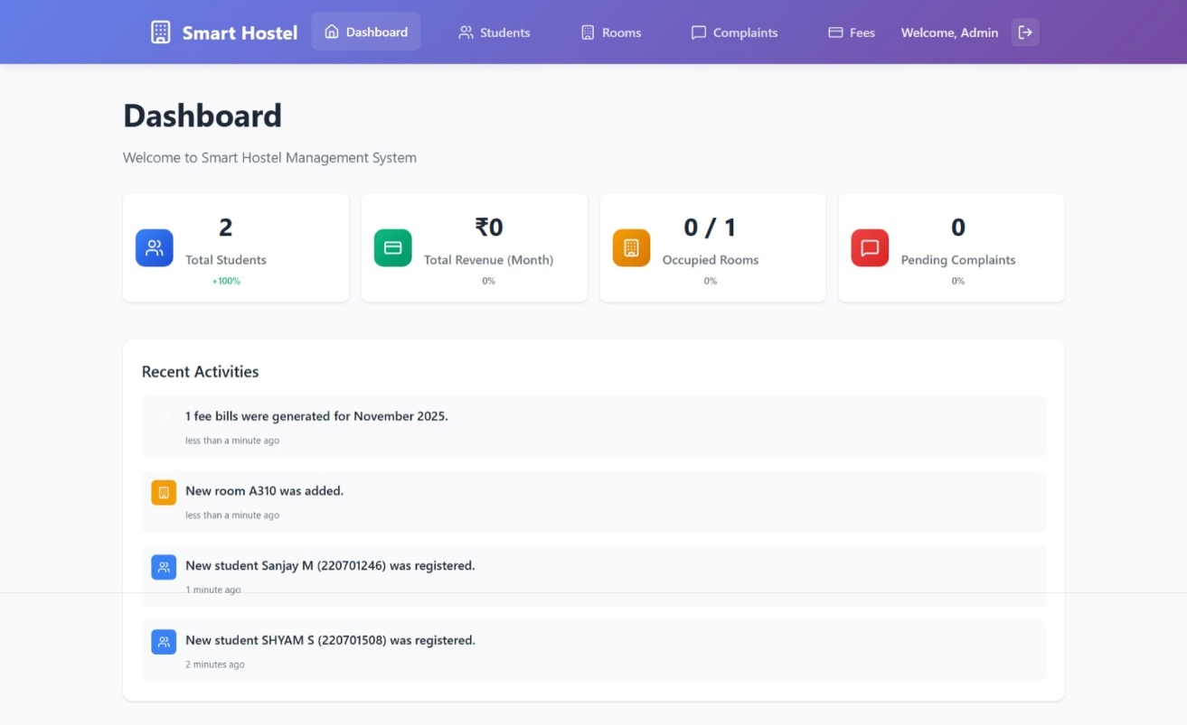
ADMIN DASHBOARD

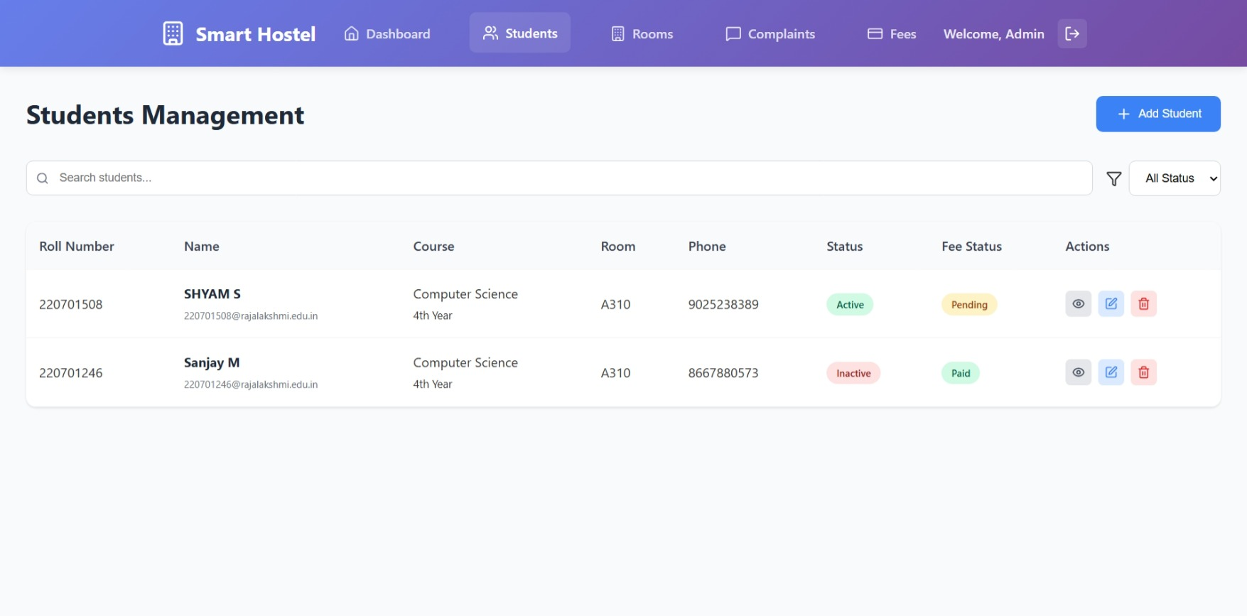
STUDENT MANAGEMENT PAGE
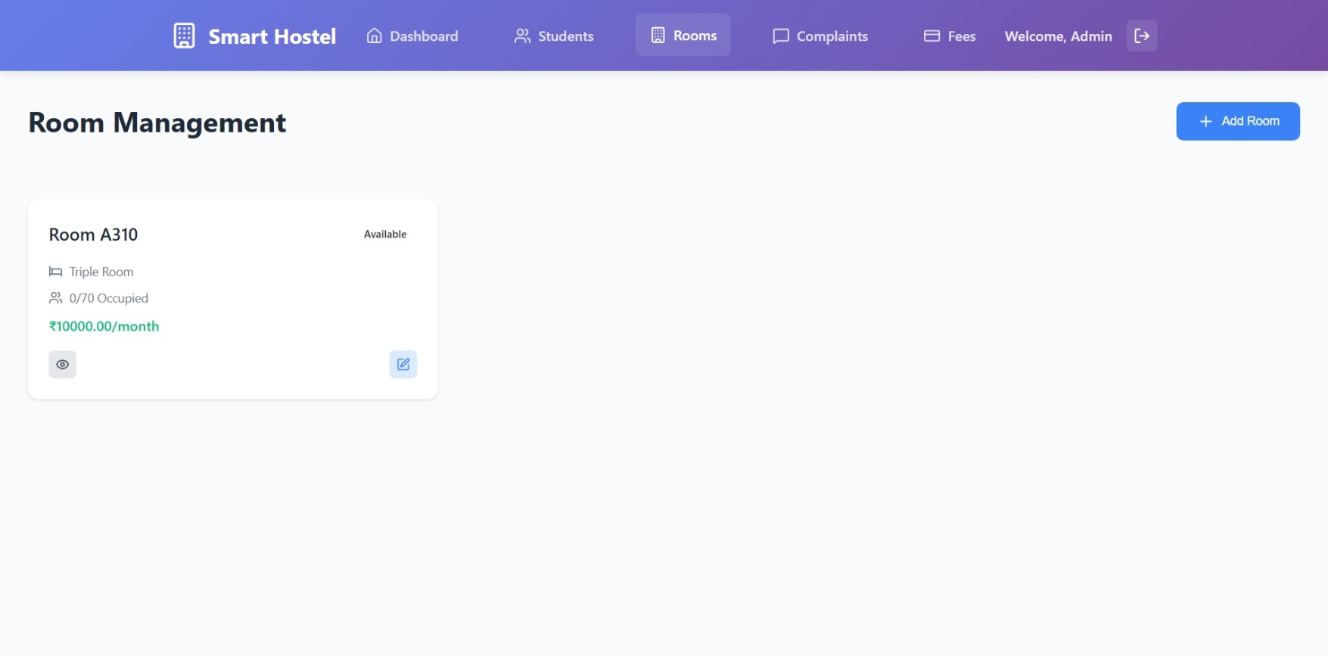
ROOM MANAGEMENT PAGE

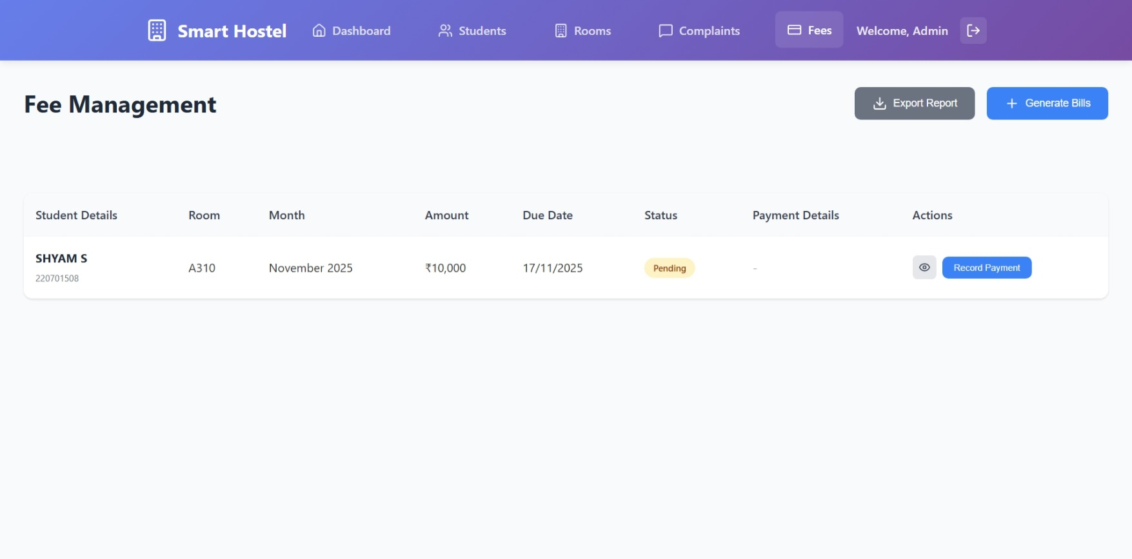
FEES MANAGEMENT

